Req 1

SELECT SUM( population_2010 )   
FROM `communes`

Req 2

SELECT Count( * )   
FROM `communes`   
WHERE `num_departement` = "94"

Req 3

SELECT `Nom_commune` , `population_2010`   
FROM `communes`  
ORDER BY `Surface`   
LIMIT 2

Req 4

SELECT `Nom_commune` , `population_2010`   
FROM `communes`   
ORDER BY `population_2010` DESC   
LIMIT 2

Req 5

SELECT `Nom_commune` / `Surface` AS densite  
FROM `communes`   
ORDER BY densite DESC   
LIMIT 2

Req 6

SELECT `num_departement` , COUNT( * ) AS nb_communes  
FROM `communes`   
GROUP BY num_departement  
LIMIT 0 , 30

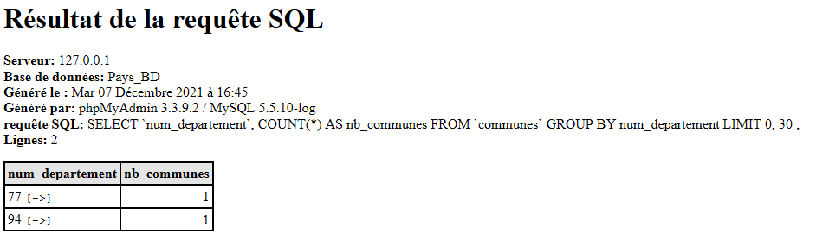

Req 7

SELECT `num_departement` , SUM( `population_2010` ) AS population  
FROM `communes`   
GROUP BY `num_departement`   
HAVING population >10000  
ORDER BY population DESC

Req 8

SELECT departement.nom, region.nom

from departement

JOIN ON REGION (departement.num_region = region.num_region)

WHERE

Region.nom_region = ‘Ile de France’ OR  Region.nom_region = ‘Pays de la loire’